A A R O N L O E B
Desainer Grafis
I’m a graphic designer who loves turning ideas into visual stories. My passion is creating clean, creative, and meaningful designs that connect brands with people.

C O N T A C

123-456-7890

hello@reallygreatsite.com

Education

Bachelor of Business Management
Borcelle University

2016 - 2020

123 Anywhere St., Any City

E D U C A T I O N
Lorem ipsum dolor sit amet, consectetur adipiscing elit. Nunc sit amet sem nec risus egestas accumsan. In enim nunc, tincidunt ut quam eget, luctus sollicitudin neque. Sed leo nisl, semper ac hendrerit a, sollicitudin in arcu.
Bachelor of Business Management

Borcelle University
2020 - 2023

Fauget High School, 2020
Science major

Borcelle University, 2024
Bachelor of Visual Communication Design
Lorem ipsum dolor sit amet, consectetur adipiscing elit. Nunc sit amet sem nec risus egestas accumsan. In enim nunc, tincidunt ut quam eget, luctus sollicitudin neque. Sed leo nisl, semper ac hendrerit a, sollicitudin in arcu.

Experience

Product Design Manager

S K I L L S
Arowwai Industries
2016 - 2020

Illustration Design
Social Media Optimization
Lorem ipsum dolor sit amet, consectetur adipiscing elit. Nunc sit amet sem nec risus egestas accumsan. In enim nunc, tincidunt ut quam eget, luctus sollicitudin neque.
Marketing Manager

Creative Advertising
Arowwai Industries
2019 - 2020

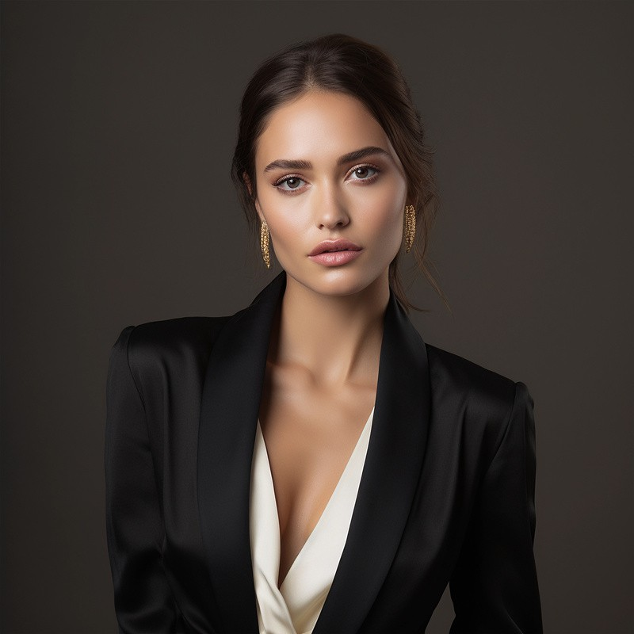






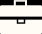

Copywriting
Lorem ipsum dolor sit amet, consectetur adipiscing elit. Nunc sit amet sem nec risus egestas accumsan. In enim nunc, tincidunt ut quam eget, luctus sollicitudin neque.

